Topic – General Insurance System

Domain - Finance

Project Abstract & Problem Statement:

The existing insurance systems require an agent to act as a mediator between the insurance company and the customer. This leads to extra charges of payments in terms of brokerage and token money to the customer. There is no existing provision for tracking the status of insurance application of the customer. The customer document verification needs to be done by the agent by manually visiting the customer or by having the customer visit the company centre.

LTI Insurance is a project under finance domain developed in order to remove all the existing problems prevailing in the current insurance firms. The aim is to develop a user friendly, secure, error free online application where the user can buy insurance policies, renew them and claim the insurance. The user will also be able to read detailed yet easy to understand excerpts about different insurance policies provided by the application.

This application is will be developed to cater to the needs of customers who are looking for an easy to use and responsive web application in order to buy vehicle insurance or travel insurance.

Mandatory Modules:

1. Buy insurance
2. Renew insurance (Only motor)
3. Calculate insurance estimate
4. Claim insurance

* Buy insurance

The user will be able to click on which insurance he wants (motor insurance or travel insurance). Accordingly, he will be asked to fill necessary information. Then a payment will be made to LTI Insurance for the respective insurance policy. Finally, a policy number will be generated, and the user will get insurance on his vehicle or traveling. 

* Renew insurance (only for motor)

The user will be able to renew his insurance policy after it is expired. User must click on renew insurance link, enter his previous policy number and make payment according to the value of his policy. Thus, the policy will be renewed.

* Calculate insurance estimate

In case the user is not sure about buying insurance and just wants to know the value of his desired insurance policy, he can simply choose the type of insurance (motor or travel), enter the required information and generate the price of the policy.

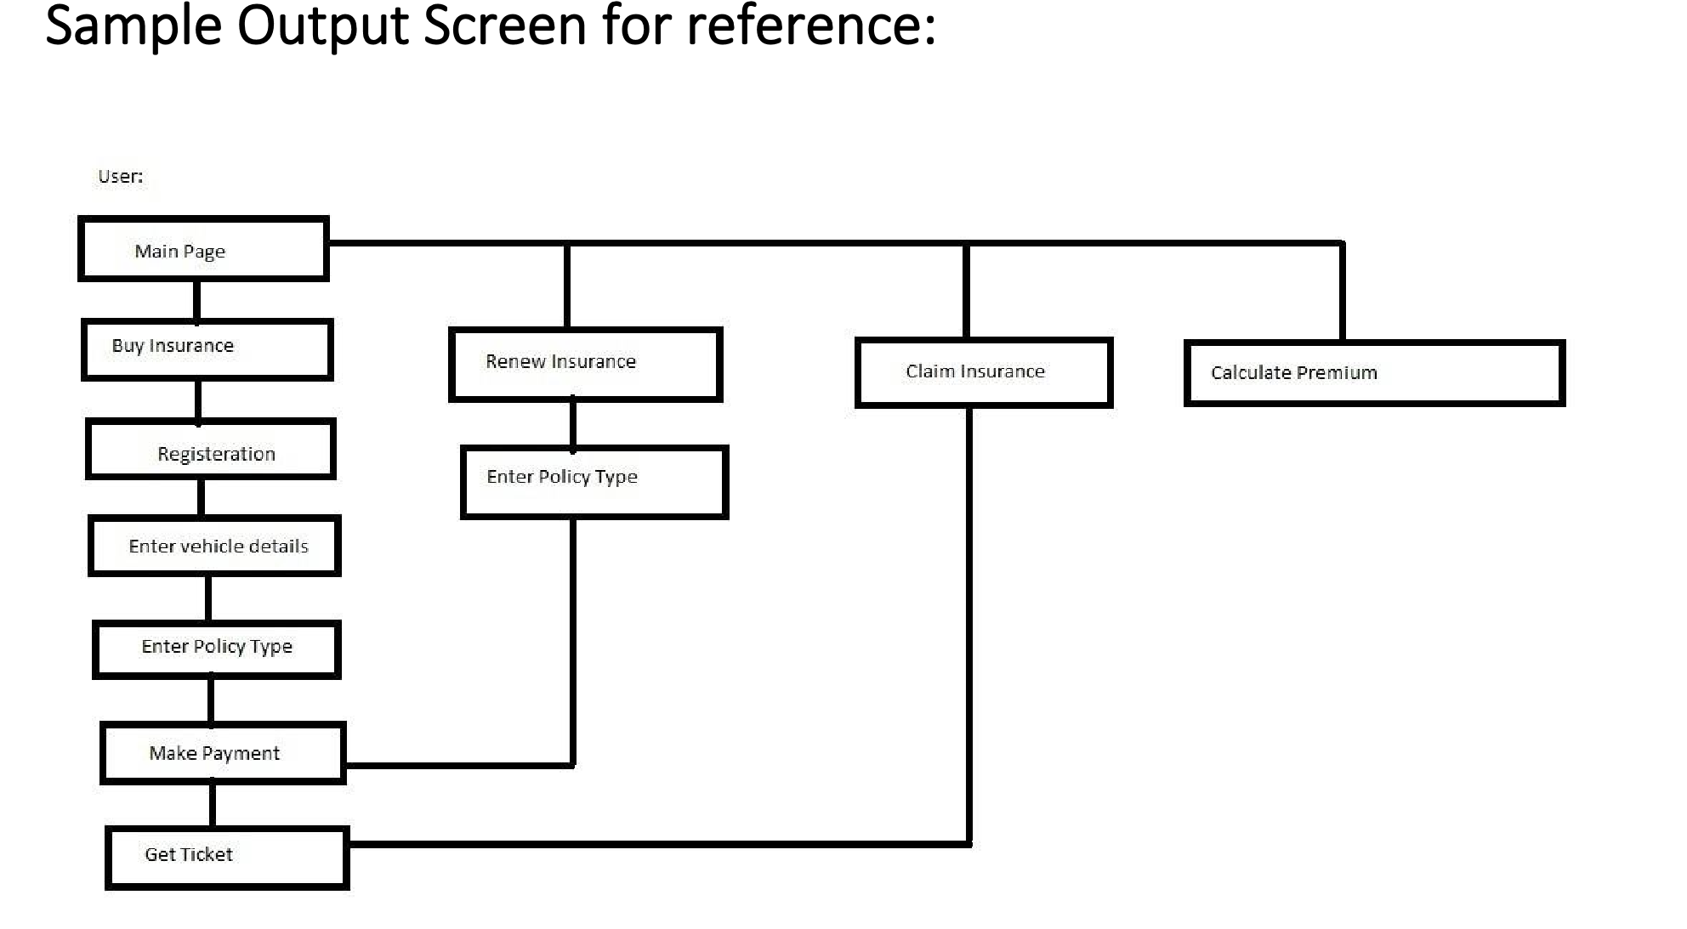

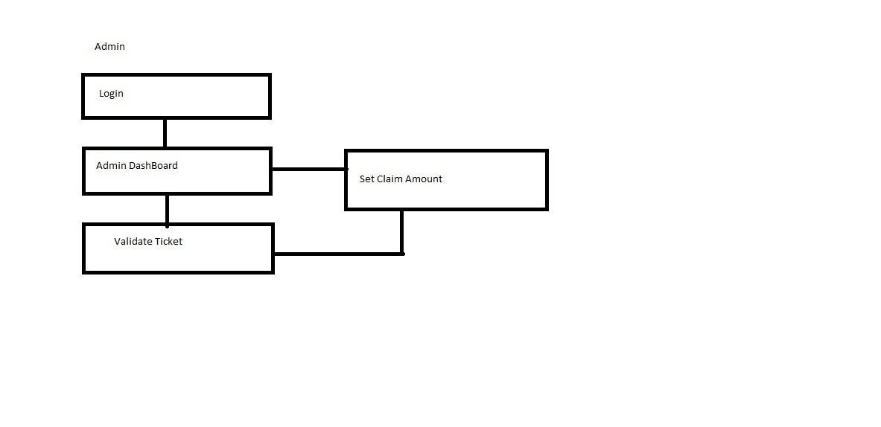

# Homepage

Login

Contact

About Us

Help

FAQ

Buy Insurance

Renew Insurance

Estimate

Insurance

Calculation

Claim Insurance

Why Insurance?

Vehicle Insurance

LOGO

# Buy Insurance

When the customer clicks on Buy Insurance, he must select weather he wants to buy insurance for 2wheeler or 4wheeler. Then he must fill the detailed information about vehicle.

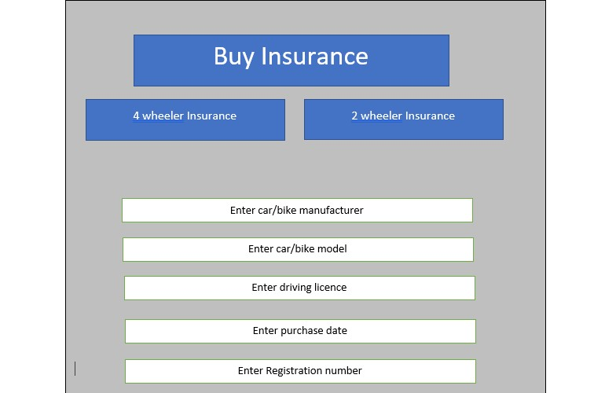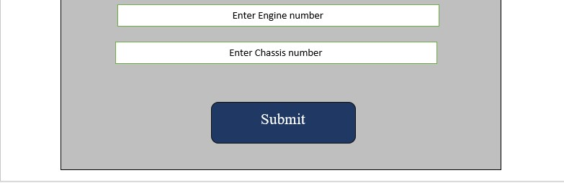

After entering vehicle details, customer must select the plan and duration of the Insurance and make payment for the same.

|  |  |  |  |  |  |  |  |  |
| --- | --- | --- | --- | --- | --- | --- | --- | --- |
| |  | | --- | | Plans |     Choose your plan     |  |  |  | | --- | --- | --- | | Third Party Liability |  | Comprehensive |   Choose you  r   |  | | --- | | One year |      |  | | --- | | Two year |   Registered customer can login into this application by entering appropriate Email ID and password.   |  | | --- | | Three year |         Renew Insurance   |  | | --- | | Make Payment |   If existing Customer wants to Renew the policy, then they need to enter the following details and select plan and duration of Insurance and make payment for the same. |

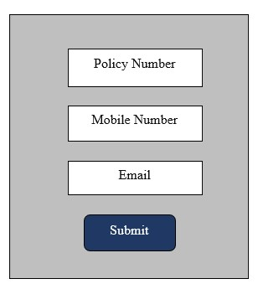

|  |  |  |  |  |  |  |  |  |
| --- | --- | --- | --- | --- | --- | --- | --- | --- |
| |  | | --- | | Plans |     Choose your plan     |  |  |  | | --- | --- | --- | | Third Party Liability |  | Comprehensive |   Choose you  r   |  | | --- | | One year |      |  | | --- | | Two year |   Registered customer can login into this application by entering appropriate Email ID and password.   |  | | --- | | Three year |          |  | | --- | | Make Payment |       Claim Insurance    Customer must specify the reason of claiming the Insurance. |

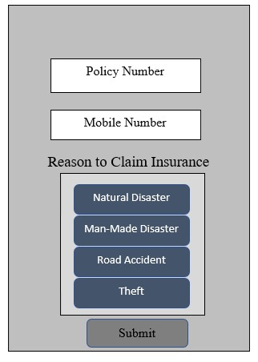

# Claim History

Estimate Insurance Premium Calculation

Claim History

Claim No

Date

Approved/NotApproved

Amount

Claim

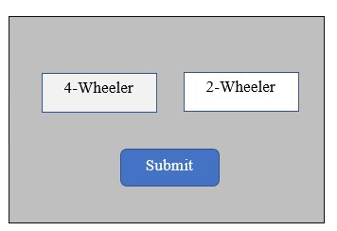

## Premium Calculation for 4wheeler

Car Model

Age

Calculate Premium

## Premium Calculation for 2wheeler

Age

Calculate Premium

Bike Model

# Login

Login

Email

Password

Forgot

Password

Login

Reset

Password

# User Page

After login, existing customer can view the details of their Insurance Policy

Policy Number

:

#

Vehicle Model: #

Registration Number

:

#

Claim Amount

:

INR__

Claim



Renew



# Registration

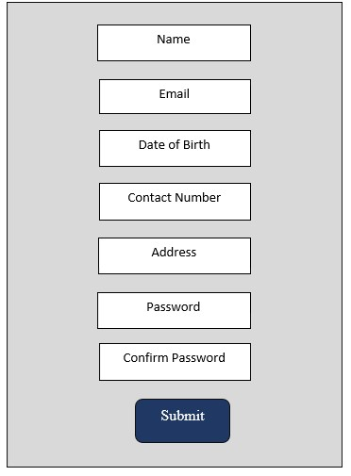

## Forgot Password

Email ID

Captcha

Submit

# Reset Password

|  |  |  |  |  |  |
| --- | --- | --- | --- | --- | --- |
| |  | | --- | | Email ID | |  | | New Password | |  | | Confirm Password |   Reset |

Agile Methodology:

Abstract:

Agile development is a group of software development methodology based on iterative and incremental development, in which requirements and solutions evolve through collaboration between self-organizing, cross-functional teams.

Steps to follow in Agile methodology:

* You need to identify various user stories and its modules/tasks which needs to be implemented in the project as a part of Sprint planning.
* Divide all the user stories in two Sprints. Duration of each Sprint will be 3 days.
* Any backlogs of Sprint 1 should be included in Sprint 2 along with stories of Sprint 2.
* You need to prepare Scrum boards for each sprint. You can include both sprints in one scrum board if there is enough space for the same.

Instructions for writing scrum board:

* Chart papers, sketch pens, measurement scale and sticky notes will be provided for scrum board preparation.
* You need to decorate your scrum board well and it should be clean, visible and self-explanatory.
* Discover a unique name for your project.
* Mention Group Number, TL and group member’s name in the scrum board.

Format for Scrum Board:

|  |  |  |  |  |  |  |
| --- | --- | --- | --- | --- | --- | --- |
| Your Project Name   |  | | --- | | Logo, if any |   Team Leader: <Name>  Group Members:  1.  2.  3. | | | | | |
| User Story | TO DO | In Progress | Impediments | To Verify | Done |
|  |  |  |  |  |  |